Case 4-EUR-Greece-Seated Woman-Attic culture- 525–500 BCE

Greek Terracotta Statuette of a Seated Woman
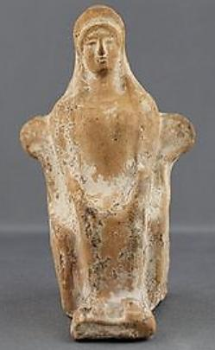
Greek votive statue in terracotta of a woman seated. Himation around her head, both hands on her knees and feet resting on a footrest. Traces of white slip remaining. Measures 4.9 inches in height and in excellent condition!
For a similar item see; The Metropolitan Museum of Art; "Terracotta statuette of a seated woman" Accession Number:59.48.3
Value $1500 Galleria Delvecchio Ancient Art www-galleriadelvecchio-com Oct. 2015

